Lab 5: FIRST PRINCIPLES MODELING

EEE4514

Marcel 1, 2017

**Gabriel Stroe**

# Filtering

## Overview

The purpose of this lab is to create a system that matches the servo motors physical properties. By using basic physics equations, we should be able to understand exatly how the rotary motor works and create a matching system.

## Theory and Methods

## Results

As can be seen in the graph bellow, our created curve matches the curve produce by the servo motor very closely. (Servo is in yellow, Our function is in pink) Since this system is has more variables then that in LAB 4 and because there are a few values we declared as negligible in the beginning of this lab, it’s not quite as a close fit as te last lab showed. In addition the last lab had us build a model based on the servo’s actual current output, this one is based on the servo’s theoretical output and does not take into account its current wear and performance.

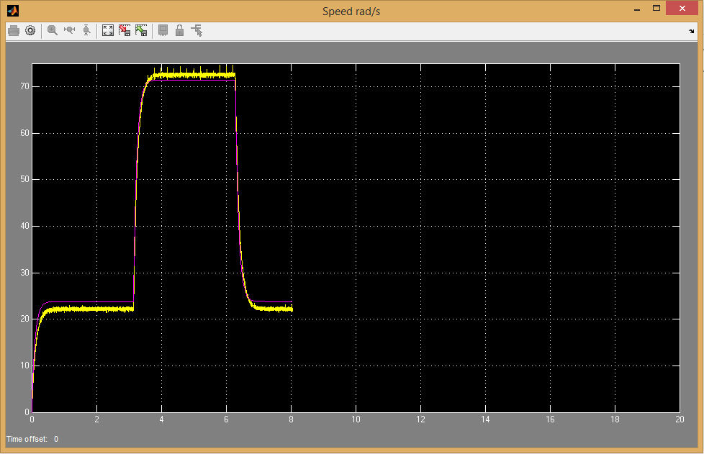

## Questions

## Conclusions

From this lab we have learned that we can use the results of any specific system (the servo motor for this instance) and derive transfer functions in how that system works. In addition, it shows how we can use computer simulations to model exactly how any system would act. This understanding seems to be critical to the basis of controls engineering.